* **Activity 6:**

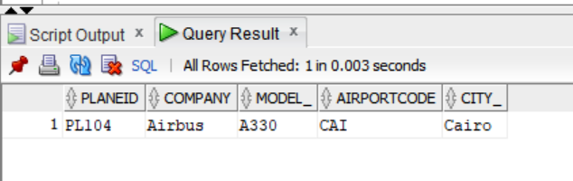Using the ORDER BY Clause in Set Operations

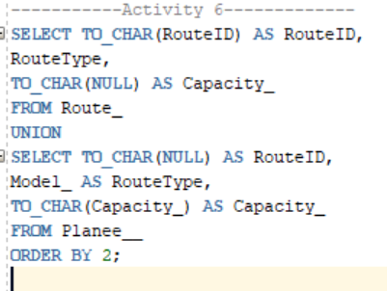

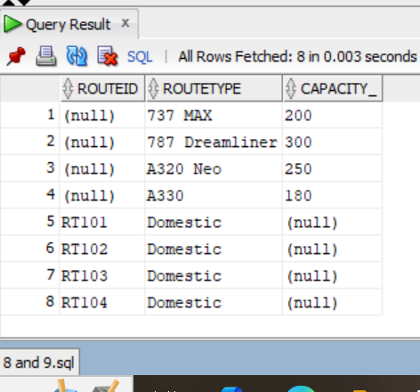OUTPUT: